FARDEEN NS KHAN
Project Report
Responsible AI Project
AI Ethics Chatbot

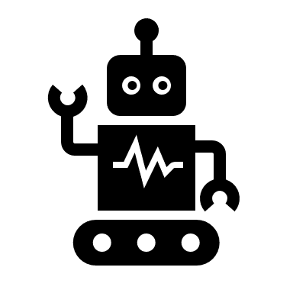
AI Ethics Chatbot

Content for chatbot flow-:
• Smart chatbot focused on AI ethics
• Answer questions about ethical use of AI
• Provide practical advice in real-world situations
• Explain why it gave a certain answer
• Detect user intent (bias, fairness, privacy)
• Understand domain context (healthcare, finance, etc.)
• Give domain-specific recommendations
• Clarify complex policies in simple language
• Provide scenario-based guidance
• Maintain transparency using explainable AI
• Show reasoning behind responses
• Handle follow-up queries and maintain context

Architecture Overview:
Understanding the flow of chatbot through architecture how will this chatbot work and what will this go through, overall, a pre to post flow
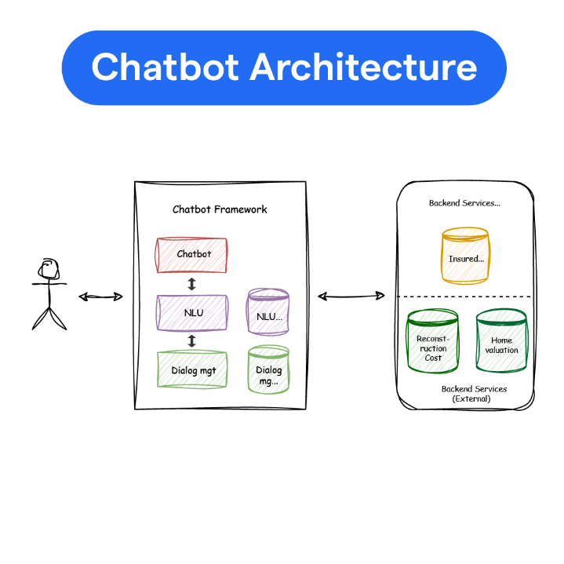
• User asks a question related to AI ethics
• Chatbot receives input through interface
• NLU identifies intent (bias, fairness, privacy, etc.)
• System detects domain (healthcare, finance, etc.)
• Ethics knowledge base is accessed
• Reasoning engine generates ethical recommendation
• Explainability module generates reason/justification
• Final response + explanation is sent to user
The AI Ethics chatbot starts when a user asks a question about ethical issues in AI. The input is processed using Natural Language Processing to understand the intent and identify the domain of the query. Based on this, the system accesses an ethics knowledge base containing rules and guidelines. A reasoning engine analyzes the situation and generates appropriate ethical recommendations. Along with the answer, an explainability module provides the reasoning behind the response, ensuring transparency. Finally, the chatbot delivers both the solution and its explanation to the user.

